Cardiovascular Health & Sleep Initiative
Newsletter Copy & Image – Health Care Professionals

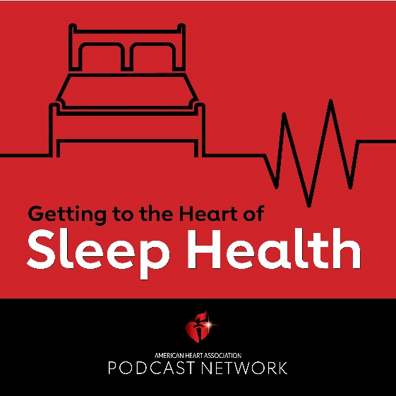

Insomnia Insights: Navigating Sleep Disorders for Healthcare Professionals

Sleep quality is consequential to cardiovascular health. Studies show short sleep duration or poor sleep quality are associated with high blood pressure, elevated cholesterol and atherosclerosis. Learn more in this vodcast from the American Heart Association about the characteristics and etiologies of insomnia. We also discuss how to assess insomnia in an office visit and what other conditions may present with insomnia.

